**Homework Assignment: Build a Website using HTML, CSS, JavaScript, and Bootstrap**

**Objective:**

The goal of this assignment is to create a responsive personal portfolio website using HTML, CSS, JavaScript, jQuery, and Bootstrap. The website will showcase programming skills, projects, and achievements. The focus is on creating a visually appealing, interactive, and mobile-friendly website.

**Image for Objective Section:**

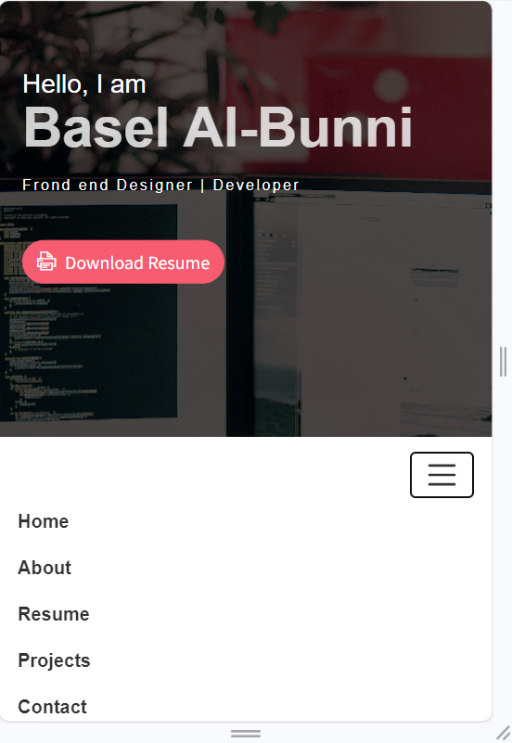

**Task:**

The task involves building a personal portfolio that includes a homepage, projects page, about me page, contact page, and navigation menu, ensuring that the design is responsive and user-friendly.

**1. Homepage**

Create a homepage that introduces yourself, your skills, and your interests. The homepage should serve as an introduction and give a brief overview of your personal and professional profile.

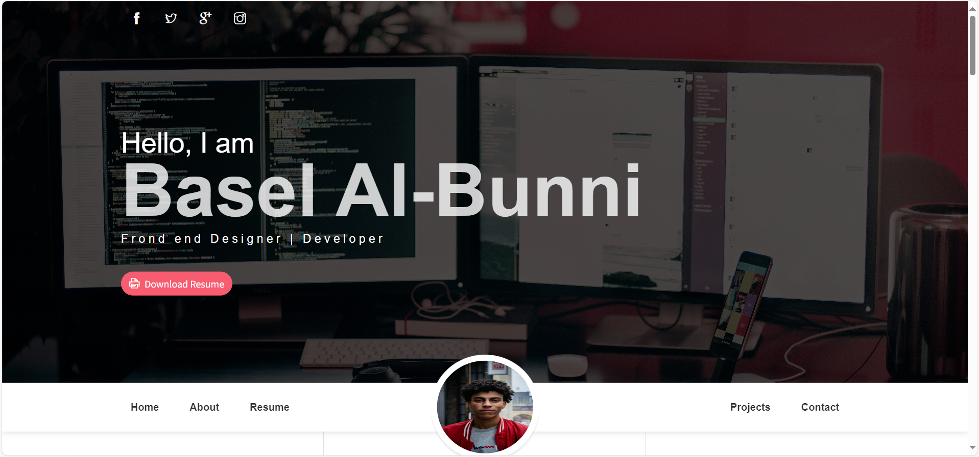

**2. Projects Page**

The projects page display all coding projects with details like the project title, description, and a link to either the project or the code repository (e.g., GitHub).

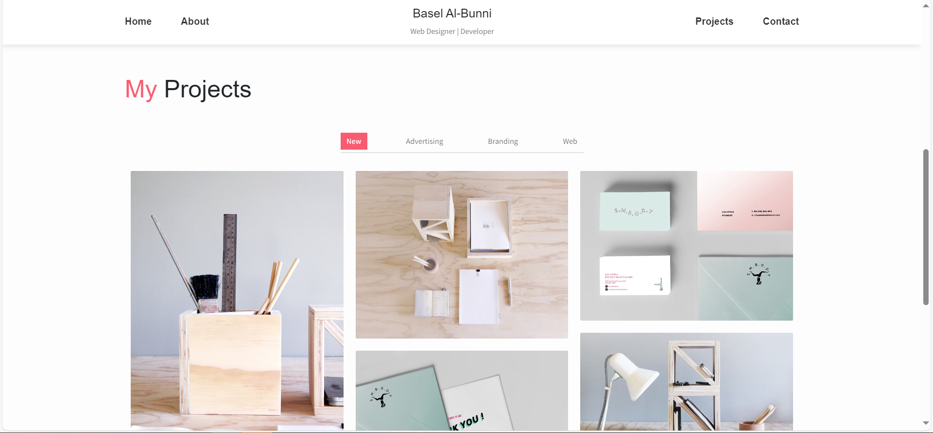

**3. About Me Page**

This page provide detailed information about my background, journey in programming, and my overall goals. It is an opportunity to showcase my personal story.

**4. Contact Page**

The contact page will include a form where visitors can send messages. Implement JavaScript to validate the form inputs before the user submits the form.

**5. Navigation Menu**

The website will have a navigation menu that allows users to seamlessly switch between different sections and pages of the website.





**6. Responsive Design**

My website fully responsive. This means it look great on devices of all screen sizes, such as desktop computers, tablets, and mobile phones using bootstrap.

**7. JavaScript and jQuery Tasks**

You will implement several features using JavaScript and jQuery, including:

* **a. Slideshow/Carousel**: Add a functional slideshow or image carousel to showcase visuals.

* **b. Interactive Element**: Use jQuery to create an interactive element such as a button that toggles the visibility of additional content on the About Me page.

* **c. Animation/Transition**: Implement an animation or transition, such as an image fade-in or text transition.

